PROPOSAL FOR COOPERATION WITH BRAZIL

POSITION :Engineer in the Corot mission Center development

PLACE , DURATION : Integrated in the Corot Mission Center team in CNES Toulouse
Arrival in Toulouse : September 2002 (the best) ; January 2003 (acceptable)
End of activities in Toulouse : December 2005

DESCRIPTION : To ensure interfaces with the COROT instrument specialists,

To write calibration software tools detailed specifications for COROT mission center,

To develop the calibration operational software tools which will be integrated in the COROT mission center.

REQUIRED SKILL : Engineer or doctorate in physics
Work experience : minimum three years in industry or in a scientific laboratory

Programming languages : C, C++, Java, IDL
Operating system : UNIX, LINUX
Computers : SUN, PC

Skills in optical instrument measurements and calibration will be appreciated,
Knowledge of astronomy scientific laboratories is desirable,
French or English language is necessary

CONTACT PERSON : ALAIN GABORIAUD
COROT GROUND SEGMENT MANAGER
Phone number : + 33 5 61 28 21 36
E-mail : Alain.Gaboriaud@cnes.fr

PROPOSAL FOR COOPERATION WITH BRAZIL

POSITION

Engineer to work in Data reduction and Instrumental Corrections (ICW)

PLACE , DURATION

Observatoire de Paris at Meudon
End 2002 to end of 2004

DESCRIPTION
The ground segment is composed of several parts, as seen on the scheme next page.
The Corot Mission Centre is under the responsibility of CNES but with a large participation of laboratories, and the Corot Data Centre is under the responsability of the PI and completely developed and managed by laboratories.

The data flow is the following:
* Level 0 (N0) is delivered by the CCC to the CMC, (scientific data+ housekeeping)
* The CMC is in charge of "instrumental corrections" as seen on the following scheme using ground and on board calibrations, and housekeeping data, leading to level 1 (N1).
* The CDC receives these data and produces the final level (N2) through a preliminary scientific treatment. After validations this second level (N2) is delivered to the Co-Is and then
To the international community, in agreement with the Data Right Policy.

The Instrumental corrections workpackage (ICW) belonging to the CMC is under the responsibility of the Instrument scientist Michel Auvergne (Observatoire de Paris-Meudon).

The ICW is in a phase of definition.
The main corrections presently foreseen are:
- Corrections of the temperature variations of several sub-systems

*Variations of the pupil surface.
*Variations of the quantum efficiency of the CCD
*Variations of the gain and of the offset of the readout electronic.
For instance, several temperature probes on each subsystems will measure temperature with a precision of 0.005 K. Those housekeeping data will be processed with the help of thermal model to deduce the temperature of the sensitive component from the probes temperatures. As, for instance, the temperature of the CCDs cannot be measured directly because it is impossible to put probes inside the CCD silicium.

- Corrections of the frequency drift of the on board clock.

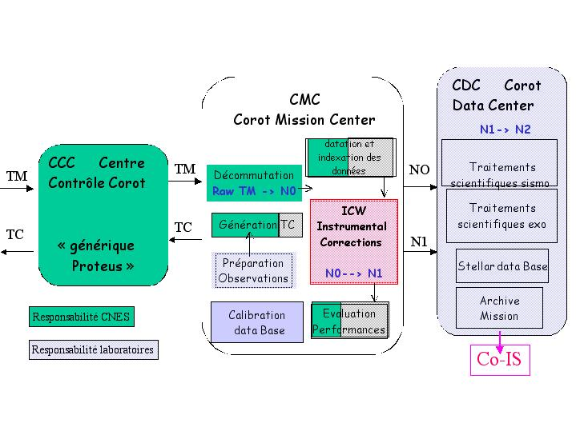
- Corrections of the satellite attitude fluctuations
The effect of the spatial non-uniformity of the quantum efficiency of the CCD, when the image position varies on the detectors cannot be corrected by the use of the classical flat field method, the bandwidth of the instrument being too large (370-950 nm).
On the exoplanet channel, three colours, blue green and red, are extracted from small spectra. The wavelength limit of each colour depends on the position of the spectra on the CCD.

The algorithms definition and validation are based on two main tools:
* A global model of the instrument, which includes the knowledge, acquired during the technical studies and the environmental perturbations.
* The CCD calibrations, made on a CCD test, bench in Paris-Meudon Observatory.
The processing method will be validated with the data produced by the model of the instrument. This model will evolve along the life of the project to include the real characteristics of the subsystems.
The development of the ICW will mainly consist in three steps:
Definition and validation of the algorithms in 2002
Development of a mock-up in IDL in 2003
Verification and delivery to the Spanish company in charge of the development of the global operational software of the CMC.

REQUIRED SKILL
It would be desirable that the candidates have already some experience in writing robust software's in the high level language IDL.
Knowledge on signal and/or image processing would be very helpful as well as some interest in the physics of the CCD detectors.

CONTACT PERSON
Michel Auvergne michel.auvergne@obspm.fr 33 1 45 07 78 69

PROPOSAL FOR COOPERATION WITH BRAZIL

POSITION

Software Engineer

PLACE , DURATION

Observatoire de Paris at Meudon,

5 place J. Janssen 92195 Meudon France.

2 years starting from january 2003

DESCRIPTION

The person will contribute to define and realize a part of the SGSE (Software Ground Support Equipment), in providing a high level simulator of TeleCommand and Telemetry processing for the integrated system including the payload and the Proteus platform simulator (EGSE and DHU simulator).

This TC/TM simulator will have the same functionnalities as the software which will be used in the Corot Mission Center (CMC) to control the payload and the flight operations. This simulator will also be used as a demonstrator for the CMC software and interface

The following layout shows the place of the software to be written in the simulation chain (lower boxes) and how it compares to the operationnal configuration (upper boxes).

REQUIRED SKILLS

C++ builder/ windows NT 2000
Industrial data processing
Interface driving.

CONTACT PERSONS

Gérard Huntzinger responsible for EGSE
(e.mail : Gerard.Huntzinger@obspm.fr )

Remy Bellenger responsible for the payload command/control
(e.mail : Remy.Bellenger@obspm.fr)

PROPOSAL FOR COOPERATION WITH BRAZIL

POSITION

2 Scientists / Engineers to work in the Corot Data Center

PLACE , DURATION

Observatoire de Paris at Meudon and Laboratoire d’Astronomie Spatiale at Orsay
and/or Laboratoire d’Astronomie Marseille

End 2002 to end of 2004

DESCRIPTION
The ground segment is composed of several parts, as seen on the scheme next page.
The Corot Mission Centre is under the responsibility of CNES but with a large participation of laboratories, and the Corot Data Centre is under the responsability of the PI and completely developed and managed by laboratories.

The data flow is the following:
* Level 0 (N0) is delivered by the CCC to the CMC, (scientific data+ housekeeping)
* The CMC is in charge of "instrumental corrections" using ground and on board calibrations, and housekeeping data, leading to level 1 (N1).
* The CDC receives these data and produces the final level (N2) through a preliminary scientific treatment. After validations this second level (N2) is delivered to the Co-Is and then
to the international community, in agreement with the Data Right Policy.

The treatments performed inside the CDC are not yet completely defined.
They will be done separately for the two chains: seismology (Meudon/Orsay) and exoplanet (Marseille).

They will include
- time, time frequency, correlations analysis......
- treatment of sequences of different length, treatment of interruptions
- collaboration with CMC if spurious effects are detected
- concatenation of sequences of the same target
- definition of procedures of validation and quality criteria before delivery to the mission Archive.
- ....

REQUIRED SKILL
It would be desirable that the candidates have already some experience in scientific data processing, and the knowledge of the high level language IDL.

CONTACT PERSON
Annie Baglin annie.baglin@obspm.fr 33 1 45 07 77 37

