Convection, Rotation and planetary Transits

A proposal for a Brazilian contribution to the ground segment of COROT.

COROT objectives and general organization

COROT is a space mission of ultra-high precision photometry dedicated to Stellar Seismology and Planet finding.
The Scientific Programme focuses on a "Core programme" aiming at the study of the seismic properties of stars on the main sequence and its vicinity and at the detection of Telluric planets, using long sequences of continuous observations of 150 days and a few shorter ones. It is complemented by "Additional Programmes" dedicated to other scientific purposes, using the same data and a few different short observing sessions.

* CNES is the prime contractor of the global mission.
* Contributions on the instrument come from Austria, Belgium, Italy, Germany, RSSD/ESTEC, ESA Scientific programme; Spain participates to the ground segment.
* A Steering Committee, composed of the representatives of the corresponding Space Agencies of CNES and the Principal Investigator, is responsible for the general development of the project, the budget, the human resources, the planning and the management.
*The Scientific Committee is responsible for the observing programme, the scientific preparation, the data reduction and data distribution. Scientific Working groups gather Scientific Teams in charge of specific programmes, lead by a Co-Investigator.

The contribution of all these countries or laboratories are presently comparable and each of them has a representative in the Steering Committee and in the Scientific Committee; they have also 4 Co-Investigators.
It will be the case for Brazil if we agree on a contribution of comparable size.

The ground segment

The ground segment is composed of several parts, as seen on the scheme next page.
The Corot Mission Centre is under the responsibility of CNES but with a large participation of laboratories, and the Corot Data Centre is under the responsability of the PI and completely developed and managed by laboratories.

The data flow is the following:
* Level 0 (N0) is delivered by the CCC to the CMC, (scientific data+ housekeeping)
* The CMC is in charge of "instrumental corrections" (pink box) using ground and on board calibrations, and housekeeping data, leading to level 1 (N1).
* The CDC receives these data and produces the final level (N2) through a preliminary scientific treatment. After validations this second level (N2) is delivered to the Co-Is and then
To the international community, in agreement with the Data Right Policy.

The Instrumental corrections workpackage (ICW) belonging to the CMC is under the responsibility of the Instrument scientist Michel Auvergne (Observatoire de Paris-Meudon).
This proposal consists in a Brazilian contribution to development of the ICW.
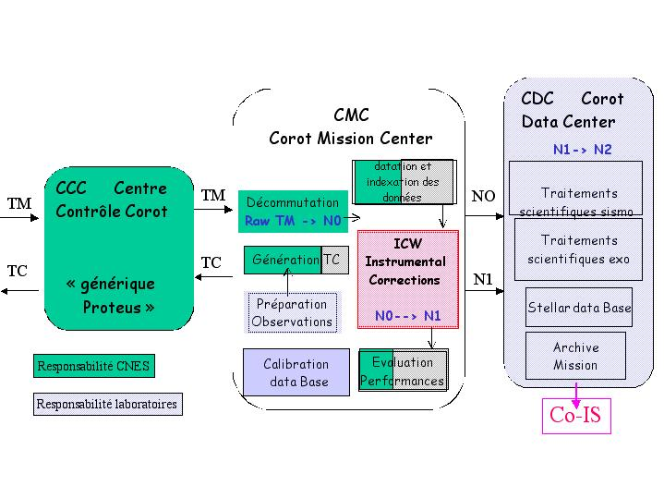

The Instrumental Corrections Workpackage

The ICW is in a phase of definition.
The main corrections presently foreseen are:
- Corrections of the temperature variations of several sub-systems
*Variations of the pupil surface.
*Variations of the quantum efficiency of the CCD
*Variations of the gain and of the offset of the readout electronic.
For instance, several temperature probes on each subsystems will measure temperature with a precision of 0.005 K. Those housekeeping data will be processed with the help of thermal model to deduce the temperature of the sensitive component from the probes temperatures. As, for instance, the temperature of the CCDs cannot be measured directly because it is impossible to put probes inside the CCD silicium.

- Corrections of the frequency drift of the on board clock.

- Corrections of the satellite attitude fluctuations
The effect of the spatial non-uniformity of the quantum efficiency of the CCD, when the image position varies on the detectors cannot be corrected by the use of the classical flat field method, the bandwidth of the instrument being too large (370-950 nm).
On the exoplanet channel, three colours, blue green and red, are extracted from small spectra. The wavelength limit of each colour depends on the position of the spectra on the CCD.

The algorithms definition and validation are based on two main tools:
* A global model of the instrument, which includes the knowledge, acquired during the technical studies and the environmental perturbations.
* The CCD calibrations, which will be made on a CCD test, bench in Paris-Meudon Observatory.
The processing method will be validated with the data produced by the model of the instrument. This model will evolve along the life of the project to include the real characteristics of the subsystems.

The development of the ICW will mainly consist in three steps:
Definition and validation of the algorithms in 2002
Development of a mock-up in IDL in 2003
Verification and delivery to the Spanish company in charge of the development of the global operational software of the CMC.

It would be desirable that the candidates have already some experience in writing robust software's in the high level language IDL.
Knowledge on signal and/or image processing would be very helpful as well as some interest in the physics of the CCD detectors.

Meudon, December 13 th 2001
Annie BAGLIN and Michel AUVERGNE
COROT Principal Investigator and COROT Instrument Scientist
Département de Recherches Spatiales, Observatoire de Paris-Meudon
92195 Meudon Cedex France
1.45.07.77.37 annie.baglin@obspm.fr

