The Brazilian Tunable Filter Imager for SOAR

Overview of the BTFI project
Presented at the Preliminary Design Review

June, 2008

Executive Summary

We are proposing to build a highly versatile, new technology, optical imaging interferometer to be used both in wide-field, seeing-limited mode and narrow-field, high spatial resolution mode on the SOAR telescope. Such an instrument opens up important new science capabilities for the SOAR astronomical community: from studies of nearby galaxies and the ISM to statistical cosmological investigations.

The Brazilian Tunable Filter Imager (BTFI) concept takes advantage of two new technologies that have been successfully demonstrated in the laboratory environment but have yet to be deployed in any astronomical instrument. The iBTF (imaging Bragg Tunable Filter) concept utilizes a Volume Phase Holographic (or Bragg Diffraction) Grating (VPHG) in double-pass configuration while the new Fabry-Perot concept involves the use of commercially available technology allowing a single etalon to act over a very large range of interference orders. Both technologies will be used in the same instrument. The combination allows for a highly versatile instrument which can be designed and constructed over a relatively short time-scale. Spectral resolutions spanning the full range between 5 and 35,000 can be achieved in the same instrument through the use of iBTFs at low resolution and scanning Fabry-Perot (FP) beyond R ~2,000. Furthermore, the BTFI system is being designed to accommodate both seeing-limited (SL) and GLAO-fed operation over the relatively large, ~3’, field of view (FoV). A Concept Design Review (CoDR) of the instrument was successfully completed in September, 2007 and the continued work plan has now advanced to this Preliminary Design Review. The work flow is divided into several phases - concept design (complete); preliminary design (to be reviewed here); final design; assembly, integration and test with a review at the termination of each phase.

While the full cost of such an instrument, including hardware and manpower, is estimated to be in the region of ~US$3M, we are planning to employ USP and INPE manpower for much of the design work bringing the total budgeted cost down to ~US$0.8M. The project is estimated to be complete within a 34 month time-frame, by December, 2009. The possibility of having the instrument work with SAM, with superb spatial resolution over a relatively large, 3’ FoV will be a powerful tool, allowing the SOAR community to conduct high impact scientific programs. Of special interest will be the study of the centers of nearby active galaxies and the study of the kinematics of galaxies in groups and clusters at redshifts 0.1-0.3 (for which a number of galaxies can be observed in only one shot). There is currently no Fabry-Perot/Tunable Filter instrument on any 4-10m class telescope which works with adaptive optics.

Please refer to http://www.astro.iag.usp.br/~btfi/index.php for a full representation of the project and its current status.

Monochromatic Hα images and velocity fields for galaxies in the nearby
universe obtained with Fabry-Perot instruments mounted on either the
1.6m OMM, 1.93m OHP or ESO La Silla 3.6m telescopes.

Document Synopsis

- A list of participants is given in the next section;
- Section 1 (Instrument Concept) gives an overview of the instrument;
- Section 2 (Science Case) describes some of the galactic and extra-galactic science that can be addressed by the instrument;
- Section 3 (BTFI Instrument Description) includes the technical specifications of the instrument;
- Section 4 (Management of the BTFI project) describes the adopted methodology for completing the instrument and its budget and time-line.

Personnel

Science Team
Claudia Mendes de Oliveira (IAG/USP)
Henri Plana (U.Santa Cruz)
Francisco Jablonski (INPE)
Laerte Sodré (IAG/USP)
François Cuisinier (Obs. Valongo)
Jaqueline Vasconcelos (U. Santa Cruz)
Adriano Cerqueira (U. Santa Cruz)
João Steiner (USP)

International Collaborators
Philippe Amram (LAM – France)
Benoit Epinat (LAM – France)
Sebastien Blais-Oullette (PhotonEtc – Canada)
Olivier Daigle (Univ. Montreal)

Instrument Team
Claudia Mendes de Oliveira (USP) – Principle Investigator
Keith Taylor (USP) – Instrument Scientist
Rene Laporte (INPE) – Optical Engineer
Cesar Strauss (INPE) – Electronics and Software Engineer
Luiz Cavalcanti (USP) – Electronic Engineer
Giseli Ramos (USP) – Software Engineer
Bruno Correa Quint (USP) – Instrument Physicist
Cesar de Oliveira (LNA) – Instrument Specialist
Fernando Lourenço (USP/INPE) – Mechanical technician
Lígia de Oliveira (LNA) – Optical technician
Javier Ramirez Fernandez (Poli/USP) – EE
Antônio Kanaan (UFSC) – Software
Fabrício Ferrari (U. Federal do Pampa, RS) - Software

- Instrument concept

The concept of a classical FP-based imaging interferometer for both kinematic work (high interference order) and tunable filter work (low interference order) is depicted in Figure 1. This will later be contrasted with the iBTF technology; however, for now, it illustrates the basic concept of a 3D data cube for both techniques. The BTFI instrument incorporates both technologies (FP + iBTF) in order to give it great versatility for a wide range of new science.

Figure 1: Illustration of how a Fabry-Perot and tunable systems work.

1.1 The TF and FP operating modes

1.1a The Tunable Filter mode (TF)

The first Tunable Filter (TF) in regular use on a 4m telescope was the Taurus Tunable Filter (TTF), commissioned fully on the AAT in 1995-97 by J. Bland-Hawthorn and H. Jones (Bland-Hawthorn & Jones 1998). More information can be found at http://www.aao.gov.au/ttf. The TTF employed a pair of low resolution FP etalons covering 370-650nm (blue range) and 650-960nm (red range). The FP etalons for the TTF were manufactured by Queensgate Instruments Ltd. and were conventional etalons other than having a small nominal gap. Unlike conventional Queensgate etalons, however, the TTF also incorporated long-range piezo-electric stacks (which determine the plate separation range) and high performance coatings over almost half the optical wavelength range. Since FPs have a periodic transmission profile, the instrument requires a limited number of blocking filters. At low resolution (R ~300), conventional broadband UBVRIz filters suffice. At the higher resolution end of the range (R = 1000), eight intermediate band filters were used to subdivide the wavelength range of each arm. Thus the TTF system was used to obtain single monochromatic images centered at a given wavelength while also providing a series of narrowband images, stepped in wavelength.

The flexibility of TFs is well-suited for narrowband astronomical imaging in lines such as [O II]
3727, [O III] 5007, Hα, [N II] 6583, [S II] 6727 and [S III] 9069. Furthermore, they have the capability of obtaining images of spectral lines at arbitrary redshifts. In that sense, it also allows for a scanning mode, but with a broader band (compared with that typically used for kinematic studies). There are several technical problems driving the development of tunable filters for narrowband imaging over standard fixed interference filters. See Section 3 for a description of the problems and suggestions for minimizing them. This project is being supported at the moment by two Technical Training fellowships (TT-3, given by FAPESP), for recent graduate students; one in software and the other in optical engineering. One of the important tasks for one of these professionals is to research alternative techniques for tunable filter work, the details of which are also given in Section 3.

1.1b The Fabry-Perot mode (FP)

The raw data produced by a scanning FP system can be represented by a series of images of the studied object, obtained at different wavelengths (or velocities) emanating from the source. The different wavelengths are obtained by changing the spacing between the plates of the FP etalon. The observed wavelength range is isolated using an interference filter. Once calibrated, one has a spectrum for each pixel in the field. Such FP systems have been used primarily for two types of application:
- to obtain precise line profiles (R > 10,000) in order to derive the physical parameters of emission regions.
- to obtain the complete 2-D kinematics of an object.
While in the nearby universe, the Hα line is mainly used, it can be replaced by the [O III], Hβ or [O II] lines for higher redshift galaxies. Broadly the science requires the IBTF to possess the following characteristics:
- Wavelength range: 400 – 1,000nm
- Resolution: 10,000 to 30,000
- Field of view ~ 3.0 x 3.0 arcmin
- Pixel size 15μm (~ 0.12” on the sky)

1.2 Calibration and Data Reduction

We would like to emphasise that a TF, in this context, is simply a FP for which the interference order is low and thus only the central monochromatic region (Jacquinot spot) is generally used.

Calibration: The scanning FP provides spectral line profiles for each pixel in the field. In most
cases, these spectra are used simply to obtain kinematic information from the Doppler shift of a given line. The calibration process is here quite simple, since one just needs to scan a reference line, the position of which is then compared with that of the observed line at each pixel (the observed line being selected through any standard interferential filter). The detailed process has been described in Amram et al. (1995).

Data reduction: One example of a data reduction package used for FP data (http://wwwobs.
cnrs-mrs.fr/adhoc/adhoc.html) is that developed by Jacques Boulesteix called ADHOC. This package is used by several groups observing with scanning FP (e.g. IAG/USP, Brazil; UNAM, Mexico; Observatoire de Paris Meudon (OPM); Université de Montréal and Observatoire du Mont Mégantic, Québec; Byurakan Observatory, Armenia; SAO Zelenchuk, Russia). Illustrations of the data reduction process can be found at the following link:
http://www-obs.cnrs-mrs.fr/interferometrie/GHASP/ghaspdatareduction.html.

1.3 The Detector

When observing in scanning mode, it takes several hours to complete scans and as such, the observations are susceptible to changes in seeing and transparency between individual frames. The result is that the profile of the scanned line will be biased, unless the scan is rapid enough so that it can then be repeated several times to achieve the desired total exposure time. The changes in seeing and transparency will be averaged when adding all the individual frames corresponding to the same scanning step of the FP. The problem with classical CCDs is that their readout noise will be added on each individual frame and the resulting profile will be relatively noisy. Because of the read-out noise, it is impossible to scan rapidly through the channels (one has to wait for enough counts to be collected in the frame before reading it), with the result that only observations taken in highly photometric conditions are fully reliable since the changes in seeing and transparency cannot be averaged out.

In order to be able to scan rapidly through the channels, one has to work in photon counting (or electron amplification) mode with essentially no read-out noise. By far the best solution is the L3CCD (http://e2vtechnologies.com/technologies/l3vision_nojs.htm). The advantage of L3CCD in its zero noise mode over a normal CCD with, e.g. 3 electrons of read-out noise, is fairly obvious for low-light level observations. As mentioned before, this project will include two Technical Training fellowships (Bolsas TT-3, from FAPESP), for recently graduated students (in software and optical engineering). One of the important tasks for the software person will be to research the alternatives for detectors available to us.

- Science case

There are several open questions about the formation and evolution of galaxies which can be addressed with the FP mode of the BTFI instrument proposed here. A number of researchers in the Brazilian astronomical community are involved with programs in these areas and could greatly benefit from the use of such a proposed instrument.

2.1 The centers of Active Galaxies

One long-standing problem in the study of nuclear activity in galaxies is to understand how mass is transferred from galactic scales down to nuclear scales to feed the supermassive black hole. Many theoretical studies (Shlosman et al. 1990, Emsellem et al. 2003 and Knapen et al. 2005) and simulations have shown that non-axisymmetric potentials efficiently promote gas inflow towards the inner regions (Englmaier and Shlosman 2004). Recent observations have revealed that structures such as small-scale disks or nuclear bars and associated spiral arms are frequently observed in the inner kiloparsec of active galaxies (Erwin and Sparke 1999, Pogge and Martini 2002, Laine et al. 2003). The most common nuclear structures are dusty spirals, estimated to reside in more than half of active galaxies (Martini et al. 2003). An enhancement of the frequency of dusty spirals in the centers of active galaxies, with respect to inactive galaxies supports the hypothesis that dusty nuclear spirals may be a mechanism for fueling the nuclear supermassive black hole, transporting gas from kiloparsec scales down to a few tens of parsecs of the active nucleus (Knapen et al. 2000, Emsellem et al. 2001, Maciejewski et al. 2002, Marconi et al. 2003, Crenshaw et al. 2003, Fathi K. et al. 2005). This hypothesis has recently been confirmed by Fathi et al. (2006) for the specific case of the LINER/Seyfert 1 galaxy NGC1097: they kinematically
mapped streaming motions of gas towards the nucleus approximately along dusty spiral arms which are observed in HST images. Figure 2 shows the gas kinematics obtained with several mosaiced IFU fields taken with GMOS on Gemini, of the central region of galaxy NGC 1097.

There is strong interest not only in the very central regions of galaxies but also in the inner several kiloparsecs across the central region, where other features, like bars, are formed. Hierarchical merger models of galaxy evolution lead naturally to periodic replenishment (~400 Myrs) of the AGN gas supply, sustaining activity. How the gas subsequently reaches the center of a galaxy is poorly understood, though. Suggested mechanisms are only schematic but feature a fragile fueling chain that can be easily fractured on short (Myr) timescales, and indeed represent one manifestation of "feedback". To progress in our understanding of fueling, we must decode AGN dynamics, most aspects of which remain uncertain. A combination of SAM+FP and sAM+TF can be used to disentangle AGN dynamics in a unique way. The high resolution mode can be used for the detailed kinematics, using narrow lines in the spectrum, while the low-Resolution mode can be used to correct the high-resolution data from the free-spectral range jumps (i.e. set the zero point of the velocities). This has been successfully accomplished with existing Fabry-Perot/Tunable Filter systems (Amram 2006, unpublished) but at lower spatial resolution than that expected with the SAM+BTFI combination.

Another project that may benefit from the SAM+TF high resolution combination is that which involves the study of superwind signatures in nearby active galaxies. Some galaxy bulges are clearly over-pressurized by winds from a central starburst. An energetic outflow can inflate a "superbubble" that exceeds the scale height of the interstellar medium. Examples of nearby galaxies which clearly show this effect are NGC 3079, M82, NGC 253 and NGC 4438. This second form of activity/feedback is easiest to trace in edge-on, late-type galaxies, by the extensive filamentation of disk galaxies that was entrained as the hot wind swept through the bulge to the Galaxy halo. Searching a sample of late-type galaxies for superwind signatures would constrain the importance of mass exchange between galaxies and their environment. SAM+TF would trace the brighter filaments into complex disk emission. The extremely narrow filaments, which also delineate the brightest X-ray emission call for the high resolution given by the combination SAM+TF.

2.2 Nearby galaxies in clusters and groups

Over the past decade, many effects of the cluster environment on member galaxies have been established. These effects are manifest in the amount and distribution of gas in cluster spirals (Vollmer et al 2000), the luminosity and light distributions within galaxies, and the segregation of morphological types. Amram et al. (1995) and Sperandio et al. (1995) suggest that there is no clear difference between the rotation curves of galaxies close to the cluster center and those of galaxies found in the outer parts of the cluster, suggesting that the expected effect of reduction of the halo of galaxies close to the center is not markedly observed. One possible explanation is that the halo is rebuilt through accretion of gas from the intergalactic medium. Similarly, but for a different environment, Mendes de Oliveira et al. (2003) showed, using FP spectroscopy of 25 galaxies, that there was no difference between the rotation curves of galaxies in the dense environments of compact groups and those for systems in much looser environments. This was contrary to previous studies which used long-slit spectroscopy (Rubin et al. 1991), which had shown that compact group galaxies have smaller masses and mass to light ratios than their field counterparts. Those authors also clearly showed the importance of using full 2D velocity maps of galaxies (as oppose to 1D rotation curves) in the study of the kinematics of interacting galaxies.

Most of the optical observations found in the literature are based on slit spectroscopy. The advantage of 2-D FP observations over long-slit spectroscopy is well illustrated in Figure 3. The wealth of information from the FP data contrasts with the less-than-a-dozen velocity points which can be measured from single-slit spectroscopy. Mendes de Oliveira et al. (2003) has shown that obtaining velocity fields of the entire galaxy is the only way to correctly map the kinematics of interacting galaxies (even mildly interacting galaxies) given the wealth of kinematic features (non-circular motions, gas/stars misalignments, etc) found in these galaxies.

The largest sample of 2D velocity fields of galaxies at optical wavelengths obtained up to now, of 75 galaxies, was that studied by Schommer et al. (1993) for measuring galaxy distances, followed by the sample of 45 galaxies analyzed by Amram et al. (1995) for studying the behavior of galaxies in clusters and 25 galaxies studied by Mendes de Oliveira et al. (2003), for studying the Tully-Fisher relation of compact group galaxies. By now, the total number of 2D velocity fields of galaxies available in the literature must be around two hundred, observed with various telescopes and different FP interferometers. Below we describe several studies on nearby galaxies which can take advantage of the combination SAM+BTFI.

Figure 3: Rotation curve derived using full 2-D FP data (dots) compared with long-slit data (squares).

2.2a Mass distribution of galaxies and their building blocks

Long-slit observations providing rotation curves of several classes of galaxies in the nearby universe (from giant to dwarf and LSB galaxies) provide evidences that the smooth mass distribution in the galaxy core is totally incompatible with CDM models which predict galactic halos with a central cuspy concentration (see review by McGaugh 2001), as illustrated in Figure 4. The derivation of masses (and the related question: what is the mass of the merging sub-units?) and the mass distribution of galaxies are crucial to test models. Velocity fields (not only a velocity profile along one axis) of galaxy cores are needed to understand the evolutionary phases during galaxy assembly.

Figure 4: Comparison of a NFW halo (cuspy) with an isothermal halo (flat) for a dwarf galaxy in the
Sculptor group.

2.2b 2D kinematics of fine structure for galaxy modeling

The Hubble Space Telescope unveiled several nuclear structures of galaxies (such as Keplerian disks) which add to classical fine structures in nearby early-type galaxies, quite common in field objects. Most of these structures have been studied using long-slit spectroscopy and badly need a study of the 2D velocity field in order to enable a complete modeling. Although dynamical models have been produced, in order to explain the origin of these features in terms of accretion/merging events, we do not have models accounting for both photometric and dynamic evolution of the gas (in the different phases) and of the stellar components.

While other large surveys will provide 1) new deep redshift surveys which will feed new research in the field of group/cluster evolution, and, 2) photometric and spectrophotometric observations, crucial for the age determination of galaxies, the full testing of semi-analytical models awaits instrumentation which will provide the 2D galaxy kinematics of both the gas and the stellar components, with high resolution. An FP on a 4-m telescope with adaptive optics correction will provide 2D kinematics of the gas, that will give crucial information in this area.

2.2 Noncircular motions in the disks of galaxies

The Fabry-Perot technique is certainly best exploited for studying noncircular motions in a galaxy since it is the only instrument capable of detecting small scale structures in the velocity fields because of both the high spatial resolution and the high spectral resolution it offers in a relatively large field.

Let us mention for instance the sample of 7 galaxies observed by Beauvais and Bothun (1999) for studying noncircular motions. As they underline in their paper, a single data set enables to explore a large variety of effects, such as: local deviations due to the presence of a bar, shocks and streaming motions introduced by a strong spiral structure, gas motions driven by radiation pressure from young stars, perturbations produced by a lumpy mass distribution, and warping effects (Figure 5).

Figure 5: Data on NGC 1406. The top row shows the continuum, intensity, and dispersion maps, and
the bottom row shows the velocity field, the model velocity field, and the residual velocity field.

2.2d Kinematics of barred galaxies

The properties of bars, in comparison to model predictions, can be used to test the formation scenarios of bars. Comparing the barred properties with models at different redshifts will give new insight on galaxy evolution in general. In the dynamical models of bars, the bar pattern speeds are important and can be estimated observationally from stellar velocity dispersions (e.g. Debattista and Sellwood 2000). To obtain the velocity field of the bar and of the disk, the Fabry-Perot could be used.

The detailed stellar and gaseous kinematical properties of bars in terms of different orbital families are also important in the models and could probably be measured as noncircular motions in bars. Both pattern speeds and the orbital kinematics of stars in bars are presently poorly known. Also, the periodic orbital shapes of bars, important in model predictions, can be studied kinematically (Mundell et al. 1999) and compared to theoretical models as shown in Figure 6.

Presently the morphological classification of galaxies in the near-IR is in a strong phase of development. A first attempt at a rather comprehensive dynamical classification of galaxies in the near-IR was made by Block et al. 2001. Bar strength is an important parameter in the new classification system, but has so far been estimated by tangential forces for only a limited number of nearby galaxies. In the determination of bar strengths, the orientation parameters of the disk are important, which can be best determined by high resolution kinematical studies. Especially for warped interacting systems, full 2-D kinematic estimates of the orientation parameters are necessary.

With SAM-FP we will be able to study bars and noncircular motions in more distant galaxies than previously accomplished with existing instruments, because of the gain in spatial resolution it offers. However, this will be possible only for very bright galaxies at medium redshifts, since normal galaxies at z ~0.3 may already have too low flux for such a study (see section 2.3 below). On the other hand, we will be able to sample the velocity fields of nearby galaxies with a scale of a few tens of parsecs per arcsec, thus enabling unprecedented studies of small-scale structures in their velocity field, as described above.

Figure 6: Study of the bar in NGC 4151 using HI data. (a) Residual velocity field after subtraction of a
model velocity field from the observed data compared in (b) with an N-body simulation of 20 000
particles in a barred potential, viewed with the same orientation.

2.3 Kinematics of galaxies at intermediate redshifts

One of the important applications of the FP mode will be to get the kinematics of a large sample of galaxies as a function of redshift to search for traces of evolution in, for example, the Hubble sequence as a function of z, the cause for such an evolution (e.g. bars) and when it happens. This can be done up to z=0.3 with the proposed setup of SAM+FP. Specially for clusters of galaxies, the gain in having a large field of view will be enormous, with the possibility of observing dozens of galaxies in one exposure.

Especially in cluster environments, it is quite possible that the galaxies have been stripped of most of their neutral gas and that the ionized gas can provide better kinematical information than the HI, as is the case for the galaxy NGC 4579 (Chemin 2003) in the Virgo cluster (Figure 7).

Other emission lines than the Hα line, used in the Local Universe, can be used for the kinematics, such as [OIII]5007 and Hβ, up to z = 0.5 and [OII]3727 up to a redshift of 1 (λ  < 750nm). Lα1216 can also be used in the optical for z > 2. For a 4m telescope we will be limited to working up to z=0.3, for normal galaxies, unless we observe lensed objects or anomalously high-star forming objects (which is often the case of interacting systems), at higher redshifts.

Figure 7: Hα emission and velocity field for the anemic (HI deficient) galaxy NGC 4579 in the Virgo
cluster.

Figure 8 shows the kind of resolution that could be achieved with adaptive optics for a spiral
galaxy at z = 0.35, provided that enough flux is available to be measured. This should give a
sufficient number of points to derive a proper rotation curve and model the mass distribution.
Groups and clusters at redshifts 0.1 to 0.3 are ideally suited to the 3 x 3 arcmin field of SAM,
enabling the observation of several galaxies at one shot.

Figure 8: Comparison of a velocity field seen at z = 0, with a pixel size of 1” (right) and z = 0.35, with a
pixel size of 0.05” (left).

2.4 Study of the interstellar medium

2.4a Galactic and extragalactic HII regions

The study of individual HII regions in nearby galaxies is a rich field of study with Fabry-Perot
instruments and it will be more so with the unprecedented resolution of SAM-FP. An example
of such a study is shown in Figure 9.

The Magellanic Clouds offer an important case, for which the spatial resolution may be interesting, noteworthy for planetary nebulae and other compact nebulae.

2.4b Studies of Herbig-Haro objects

SAM+TF could be used to study the plasma diagnostics in the shocked Herbig-Haro flows from young stars to examine the interaction with the adjacent molecular cloud (Cecil, G. 2006) and how angular momentum is removed from young stellar environments in regions of low extinction.

Figure 9: Detailed study of an HII region in a nearby galaxy.

2.5 Conclusion

The Fabry-Perot instrument proposed for SOAR has the potential to be used for a large variety of astrophysical problems mainly related to the formation and evolution of galaxies and study of the interstellar medium.

The wavelength coverage (400-960nm) and field of view (3x3 arcmin) for our proposed instrument are quite standard values for this type of instrument. However, the possibility of having a 3 arcmin field corrected with adaptive optics is new and will make SAM+FP/TF a powerful instrument particularly for the study of the centers of nearby galaxies and clusters at redshifts 0.1-0.3 as well as for any programs that depend on narrow-band imaging of emission-line sources.

3 BTFI Instrument Description

3.1 Introduction

The proposed Brazilian Tunable Filter Imager (BTFI) represents an instrument strategy that optimizes the science potential for optical spectroscopy with the SOAR telescope, with its emphasis on high image quality and its use of Ground Layer Adaptive Optics (GLAO) for image enhancement in the optical over a wide field of view. In order to full realize the science potential that such an investment allows, it is necessary to utilize not just the superb image quality but also the field-of-view advantage of the SOAR (+ GLAO) configuration for spectroscopy. SOAR already possesses an optical imager (the SOI) at the native bent Cassegrain focus and the SOAR Adaptive Module (SAM) has a dedicated GLAO-enhanced optical imager. However we propose here the development of a wide-field tunable filter imager as an effective means of doing area spectroscopy over a wide range of spectral resolving powers on SOAR and SAM to fully exploit their science potential.

The BTFI is thus designed to supply tunable filter imaging with a field-of-view of ~3’
sampled at ~0.12” (f/7 camera):
- At direct Nasmyth: seeing-limited area spectroscopy;
and
- At SAM’s VI-port: GLAO-fed area spectroscopy.

Like many other instruments of its type, the BTFI employs Fabry-Perots (FPs) in order to achieve high spectral resolution (R < 35,000). However, in the scientifically compelling, low spectral resolution domain, exploited more recently by the Anglo-Australian Telescope’s TAURUS Tunable Filter (TTF), the BTFI will utilize a new double-pass VPH grating technology (the imaging Bragg Tunable Filter; or iBTF) to achieve ultra-low to intermediate (5 < R < 4000) spectral resolving powers in a highly efficient, cost-effective and compact configuration.

3.2 Instrument Concept

In its simplest mode the BTFI instrument is a focal reducer with a single f/16.5 collimator and dual cameras allowing the simultaneous acquisition of the filtered (F_{λ}) and complementary (T-F_{λ}) images across the observed field-of-view. (T represents the spectrum of pre-filtered light incident on the tunable filter having a tunable band-pass F_{λ}). The simultaneous acquisition of filtered and complementary images permits a robust correction for transparency and PSF variations which otherwise plague the reconstruction of photometrically accurate 3D data cubes. (The concept is best visualized in Figure 12.)

As far as we are aware, all other FP-based imaging interferometers have done without such a facility, however accuracy of the photometric reconstruction of such data cubes has been a severe limitation on the scientific utility of the resulting data. While high resolution kinematic data can, with care, be routinely obtained, an accurate, low resolution, tunable filter data cube requires not only superb photometric conditions over the time-frame of the spectral scan but also a stability of the image PSF to preserve spatial resolution through the data cube. Immunity to such atmospheric instabilities can be mitigated to some degree with photon counting detectors (eg: the original TAURUS system using the Image Photon Counting System, the FaNTOMM fast scanning system or proposed systems using E2V’s L3CCD technology) however at low resolution, standard CCDs are still required for ultimate sensitivity. Furthermore, the time spectrum of PSF variability as delivered by SAM’s GLAO system, while it may have been modeled under the range of atmospheric conditions prevalent at SOAR, will not be confirmed until the SAM system has been commissioned. Hence for a system based on long time-scale sequential wavelength scanning, caution argues for acquisition of a complementary channel.

As defined above, the second, complementary, channel (T-F_{λ}) approximates to a continuum image of the observed field and hence offers a very deep, high signal-to-noise, image which can be used to monitor the atmosphere. However, this is not the only use of the second channel; the broad-band (T-F_{λ}) light can be further filtered either with an FP or a second iBTF to allow for simultaneous wavelength scanning at a secondary spectral resolution. Provided the second channel is at significantly lower resolution than the first, it can be used both as an atmospheric monitor channel and as a second science channel offering simultaneous wavelength scans at two resolutions and/or wavelengths.

The two cameras of the BTFI thus represent a highly versatile instrument concept. The primary channel can be used for high resolution (FP) scans or low to intermediate resolution (iBTF) scans. In both cases the secondary channel can be used for atmospheric monitoring. Alternatively the accuracy of atmospheric monitoring can be traded with scientific utility by using the second channel for the simultaneous acquisition of data cubes at different resolutions and/or wavelengths. The actual usage of the BTFI will be highly dependent on the science objectives of the user. The two channel concept gives the BTFI a photometric robustness for data cube acquisition while allowing a scientific versatility that is unique amongst FPs and tunable filter imagers.

3.3 The iBTF concept

One of the most interesting features of Volume Phase Holographic (VPH) gratings is the possibility of adjusting the efficiency curve, or “blaze” function, by varying the angle of incidence. Indeed, while their dispersive properties are identical to that of classical gratings, their diffracted energy distribution is governed by Bragg’s law, as for X-rays in a crystalline structure. (Radiation that departs significantly from the Bragg condition passes through the grating undiffracted.) This tunability can be advantageously used in spectrographs, but it also allows a new type of imaging tunable filter. Using a second grating, it is possible to recombine, or “undisperse”, the light coming from the first grating. An image can be reconstructed as long as the gratings are parallel and have the same line fringe frequency (Blais-Ouellette et al, 2004). The iBTF concept is illustrated in Figure 10. Only light whose wavelength satisfies the Bragg condition is diffracted. It is then possible to adjust the grating angle, effectively tuning the filter’s central wavelength.

Figure 10. Optical layout of the Double VPH Tunable Filter. A first grating disperses collimated light that satisfies the Bragg condition. A second grating recombines the beam which is then re-imaged onto a detector.
Top: grating angle is 30º, passband is centered on 500nm for a 2000 lines/mm VPH.
Bottom: grating angle is 17.5º, passband is centered 300 nm for the same VPHs.

The advantages of an iBTF tunable filter concept over a standard Fabry-Perot (or Imaging Fourier Transform Spectrograph) based instrument are as follows:
- The iBTF is compact, robust and built from a single, custom-specified VPH grating;
- The VPH grating is very inexpensive (relative to a FP);
- Wavelength tuning is achieved through a simple rotation mechanism rather than complex and highly delicate capacitance micrometry;
- There are no internal alignment issues as contrasted with the highly critical and unstable plate alignment of FPs;
- Ultra-low (R >5) together with intermediate (R ~2,000) spectral resolving powers can be routinely achieved;
- The surface of constant wavelength approximates to a 1st order slope in the direction parallel to the dispersion axis as opposed to the complex nested paraboloids of the FP.

The only disadvantage is that it cannot achieve very high (R >5,000) spectral resolving powers if limited to standard materials and a convenient, compact format.

3.4 The Fabry Perot mode

Classical Fabry-Perots can only cover a few free spectral ranges due to the limited scan range of a few microns of the piezo-electric transducers. The technology developed for the new tunable filter by Cedrat Co. allows to enlarge the scan range of the piezo-electric from 0 (more exactly the optical contact) up to 200 microns, allowing to cover hundreds of free spectral ranges (depending on the wavelength). In summary, the new interferometer can be used as a TF (low order of interference: low resolution) and as a classical FP (high order of interference: high resolution) and may shift from one mode to the other in a fraction of second. Even if this new FP can reach low resolution (R~300), it is not in competition with the iBTF in that regime. Both will be complementary.

3.5 The BTFI instrument

An optical layout of the BTFI instrument is shown in Figure 11. Light paths of the incident, diffracted and undiffracted (0th order) beams are shown, as is the dual camera configuration which allows for the simultaneous acquisition of the complementary (or monitor) channel. The chosen 50mm pupil is compatible with readily available VPH gratings and the folds are necessary to allow the instrument to fit within the space envelope of SAM’s VI port. An EMCCD detector having a format of 1.6k² is matched to the required pixel-scale (0.12”/pixel) and field (3’).

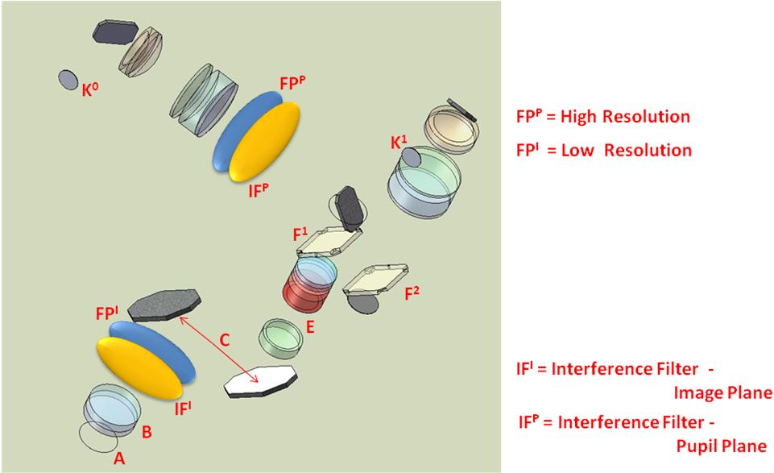
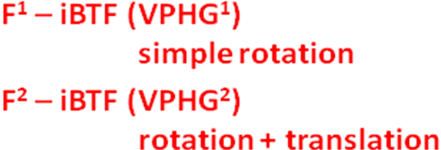

Figure 11: Proposed optical layout of BTFI showing folds (2 before collimator and 1 after iBTF) to accommodate space envelope.

3.6 BTFI performance summary

3.6a Spectral Resolving Powers

- 5 < R < 100: The lowest resolutions can be achieved with transmission VPHGs formed from Dichromated Gelatin (DCG);
- 100 < R < 200: In reflection (by a simple rotation of the VPHG pair) the DCG gratings can deliver somewhat higher resolutions;
- 200 < R < 3,000: Using doped glass rather than DCG intermediate resolutions can be achieved for a transmission configuration;
- 1,000 < R < 5,500: while in reflection, D-G gratings can deliver the highest iBTF resolutions attainable with current VPHG materials;
- 300 < R < 35,000: FPs (including FP-based tunable filters) are, in principle, unlimited at the high resolution end, however the R < 300 régime is very difficult to achieve in practice.

3.6b Efficiencies

VPHGs are intrinsically very efficient gratings (~90% at peak). Used in double-pass they are still significantly more efficient than normal surface-ruled gratings (~60%) and FPs (~70%). The efficiency of the iBTF is however a complex function of angle as it is tuned over a wavelength range – the locus of peak efficiency as a function of wavelength is known as the super-blaze. For some doped glass configurations further losses of efficiency are encountered in the material itself. Nevertheless, the BTFI concept allows for a broad range of spectral resolutions at efficiencies competitive with current techniques but at a fraction of the cost and complexity.

Table 1 gives an audit of the main throughput components from Telescope through SAM to the detectors of the BTFI.

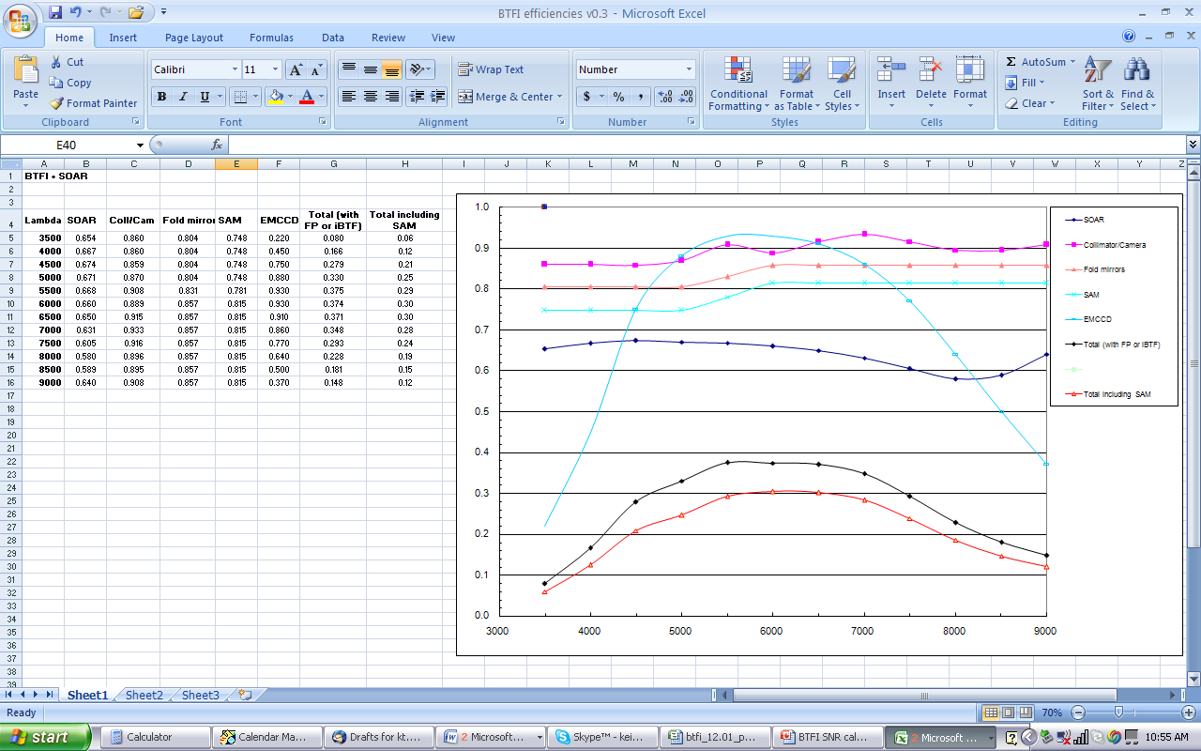

Table 1: Full system throughput as a function of wavelength.

3.7 Current Status

The iBTF concept has been successfully prototyped through an NSF grant (Award #0352991) confirming the basic functionality and applicability of the double-pass VPHG concept both in transmission and reflection modes. This prototype has now been developed into a commercial product (Photon etc, Montreal) as a laboratory tunable narrow band source and spectrophotometer for instrument and filter calibration. More recently we have developed a schematic optical layout (Figure 11) which will satisfy the space constraints of SAM’s visitor instrument port and have developed an opto-mechanical design as shown in Figure 12. In September, 2007, the BTFI project successfully passed through its Concept Design Review the panel members of which were selected from the international astronomical instrument community (see results of the Concept Design Review in http://www.astro.iag.usp.br/~btfi/documents.php). This report is an overview prepared for the Preliminary Design Review to be help at IAG/USP in June, 2008.

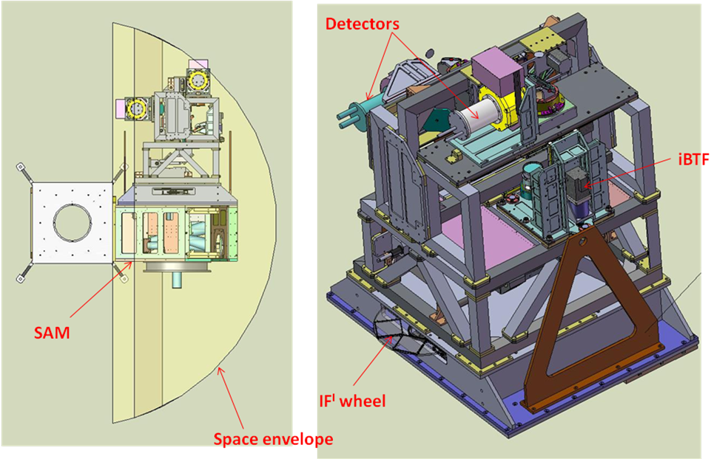

Figure 12: An overview of the instrument mechanical design. Preliminary finite element analysis has validated the structural design.

The preliminary design phase of the project is now nearing completion using an initial $80K FAPESP funding award together with more substantial funds that have been awarded by FAPESP in line with the budget as shown in Table 2.

4. Management of the BTFI Project

Instrument projects for modern telescopes have consistently suffered major delays and budget overruns. We thus have been using the experience and lessons learned from these projects to establish the BTFI project from the beginning using modern project management methodologies. A Work Breakdown Structure (WBS) was first established using a three-tier structure which allowed all the major systems and components of the project and the instrument to be included and allowed scope for inclusion of new systems as the project evolved. The development of the WBS has allowed the project’s scope to be outlined and the necessary detail to be laid out clearly before the preliminary design phase commenced. This WBS is then be used to structure the other project documentation and information.

The BTFI Requirements Document gathers together in one place the fundamental science-driven technical requirements and specifications of related systems. In the early stages of the project, this document has been used as a working document and has been revised and added to as the design evolved, and is now subject to strict project change control, revision, approval and release. This is particularly important now that the technical investigations and designs are progressing.
The BTFI project is a full end-to-end instrument project taking into account all aspects of instrument construction, commissioning and operation. The goal of the BTFI project is to deliver not only the instrument, but also:
- a structured integration, testing and commissioning plan;
- observing software tools and documentation;
- data reduction software, documentation and training;
- an instrument maintenance and technical support documentation.

The archiving, control and distribution of BTFI project documentation and information is especially important considering the distributed nature of the BTFI project. It is necessary to provide a place to store all the documents so that they can be easily reached and ensuring strict version control. A web-based documentation sharing tool was used to construct a site used by the instrument and science group.

To ensure the instrument will be delivered on-time, a detailed BTFI Project Schedule and Milestone list was developed based on the WBS structure and using time estimates based on the work laid out by the Requirements Document. The current milestone schedule for the project, as developed for the Concept Design Review is given in Figure 13.

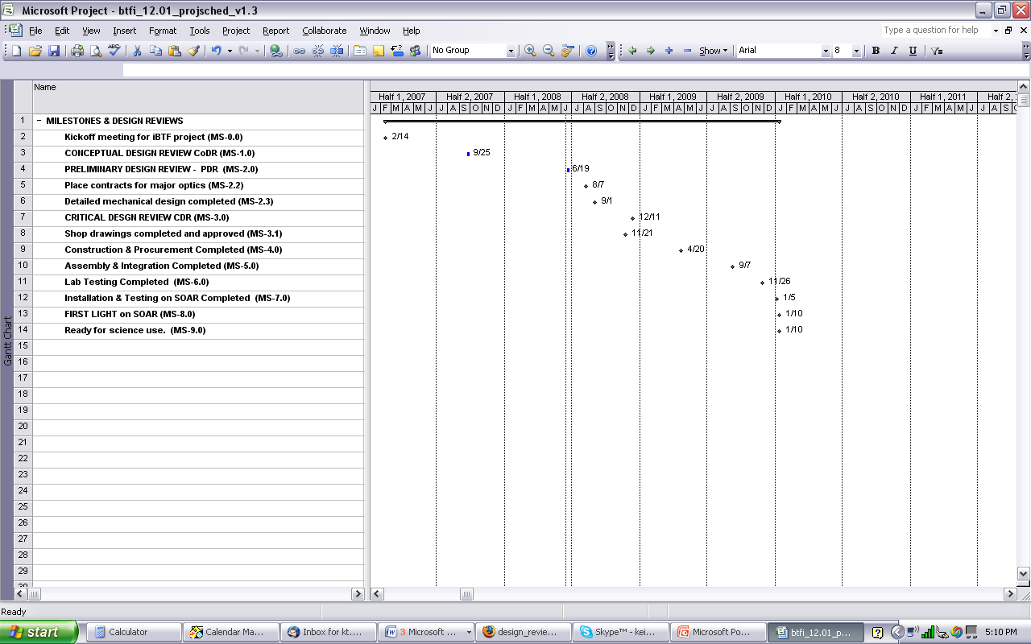

Figure 13: The top-level milestone schedule for the BTFI project.

A detailed budget for the design phase has been developed using estimates based on the instrument description, requirements and project schedule. The budget is shown in Table 2. As the instrument design develops, a more precise construction budget will be developed using a detailed bottom-up costing of individual time and work estimates. This budget will also be checked using a top-down estimate based on experience with similar instrument projects.

A Project Manager (PM) has been assigned to the BTFI project who has been given the responsibility and authority to plan, manage and coordinate the work to deliver the instrument on-schedule and within budget. Several senior engineering and scientific staff have been assigned to the project who will be given responsibility for the detailed design work of the major technical areas using a Work Package Management (WPM) system. A technical staffing requirements list for the project design phase has been developed which details the estimated resources, skills and experience required to complete the design and construction work. Suitable technical staff and contracted help have been assigned to work on the project via the WPM system.

A series of Project Reviews will be held at regular intervals to focus the project’s attention at critical times to present the technical design as well as document and report progress. Feedback and recommendations from an external review panel will provide valuable additional information and independent opinion and judgment for the project staff. Early in the design phase, the Conceptual Design Review (CoDR) was successfully complete which froze the instrument scope and requirements and prepared the project for the current preliminary design investigation. At the conclusion of this design phase, the Preliminary Design Review (PDR) will allow a thorough review of the instrument design and project progress prior to the final stage leading to project construction. Before construction commences and major purchases are made, a Critical Design Review (CDR) will assess the readiness of the design to proceed to manufacture and the status and progress of the project management.

Bottoms-up total cost = US$837,350
Hardware cost = US$679,150
Estimate In-house Labor = US$2,014,280
BTFI Equivalent TOTAL COST= US$2,851,630

Table 2: BTFI project budget (in ’08 US$). The total cost of materials and contracted labour is estimated ~US$840k, while the full (estimated) costs, including in-house labour approached US$3M.

Data reduction is a particularly important aspect of the BTFI project. The use of the Fabry-Perot and iBTF will create large datasets which must be processed correctly to extract meaningful spectral and spatial data cubes. Considerable expertise in data processing already exists within the collaborating partners of the BTFI project. Several postdocs and graduate students are being trained to adapt these software packages and to document the data reduction processes.

References

- Amram, P., Boulesteix, J., Marcelin, M., Balkowski, C., Cayatte, V., & Sullivan, W. T. III
1995, A&AS, 113, 35
- Beauvais, C., & Bothun, G. 1999, ApJS, 125, 99
- Blais-Ouellette, S., Wishnow, E. H., Shopbell, P. L.. van Breugel, W.. Taylor, K. & Smith, R., SPIE, 5492, 779
- Bland-Hawthorn, J., & Jones, D.H. 1998, SPIE, 3355, 855
- Block, D. L., Puerari, L., Knapen, J. H., Elmegreen, B. G., Buta, R., Stedman, S., & Elmegreen, D. M. 2001, A&A, 375, 761
- Cecil G. 2006 New Astronomy Reviews 49, 553
- Chemin, L., Cayatte, V., Balkowski, C., Marcelin et al. 2003 A&A 405, 89
- Crenshaw, D. M., Kraemer, S. B., Gabel, J. R. 2003, AJ, 126, 1690.
- Debattista, V. P., & Sellwood, J. A. 2000, ApJ, 543, 704
- Emsellem, E., Goudfrooij, P., Ferruit, P. 2003, MNRAS, 345, 1297.
- Emsellem, E., et al. 2001, A&A, 368, 52.
- Englmaier, P., Shlosman, I. 2004, ApJ, 617, L115.
- Erwin, P., Sparke, L. S. 1999, ASPC, 182, 243.
- Fathi K. et al. 2005, MNRAS, 364, 773.
- Fathi K., Storchi-Bergmann, T., Riffel, R. A., Winge, et al. 2006, ApJ Let., in press (astroph/0602002, and Gemini press release 2006 Feb. 1).
- Knapen, J. H. 2005, ApSS, 295, 85.
- Knapen, J. H. et al. 2000, ApJ, 528, 219.
- Laine, S. et al. 2003, AJ, 126, 2717.
- Maciejewski, W., Teuben, P. J., Sparke, L. S., Stone, J. M. 2002, MNRAS, 329, 502.
- Marconi A., Axon D.J. et al. 2003, ApJ, 586, 868.
- Martini, P., Regan, M. W., Mulchaey, J. S., Pogge, R. W. 2003, ApJ, 589, 77.
- Martini, P., Pogge, R. W. 1999, ApJ, 569, 624.
- McGaugh, S. S. 2001, in Proceedings of the Yale Cosmology Workshop "The Shapes of Galaxies and Their Dark Matter Halos", Edited by Priyamvada Natarajan. Singapore: World Scientific, 186 (astro-ph/0107490)
- Mundell, C. G., Pedlar, A., Shone, D. L., & Robinson, A. 1999, MNRAS, 304, 481
- Pogge, R. W., Martini, P. 2002, ApJ, 569, 624.
- Rubin, Vera C., Hunter, Deidre A., Ford, W. Kent, Jr. 1991, ApJS, 76, 153
- Schommer, R. A., Bothun, G. D., Williams, T. B., & Mould, J. R. 1993, AJ, 105, 97
- Shlosman, I., Begelman, M. C., Frank, J. 1990, Nature, 345, 679.
- Sperandio, M., Chincarini, G., Ramoazzo, R., & de Souza, R. 1995, A&AS, 110, 279
- Vollmer, B., Marcelin, M., Amram, P., Balkowski et al. 2000, A&A, 364, 532.

